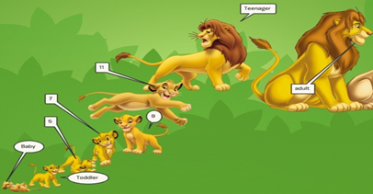
Unit 9 Development project

Objective: Understand Erik Erikson’s Psychosocial development stages.
Directions: With a partner you are to create a “dream child” and use one of the following sites on the back to create your “dream child” and document the Psychosocial stages it goes through.
Step 1: Pick a character or make up one.
Step 2: Research the different stages of Erik Erikson’s social development stages.
Step 3: You can create a power point, a Prezi, or a paper version.
Step 4: Work together in your groups on gathering information and putting it together.
Step 5: Each stage should be explained and incorporated into your characters life.
Step 6: Turn in group project with a grade sheet for each group member

